**WEEKLY REPORT DE BENEDETTI MATTEO**

**09/09/2019 – 13/09/2019**

Continued familiarization with the ROCK framework, the OROCOS toolchain and the RTT-Real Time Toolkit.

Learned how to operate the ExoTer rover [1] and deploy scripts on it.

Studied the architecture and run a simple joystick control script for ExoTer [2].

Studied the architecture of the visual odometry script for ExoTer [3] and implemented a few fixes to run the visual odometry script and minor modifications to improve the quality of life when logging data.

Performed a preliminary experiment to evaluate the visual odometry script and implemented a simple matlab script [4] to visualize the results.

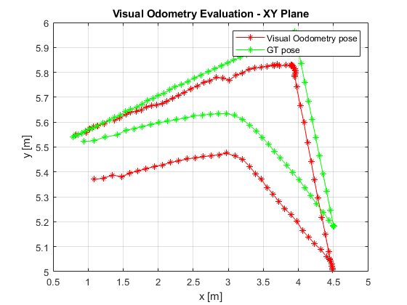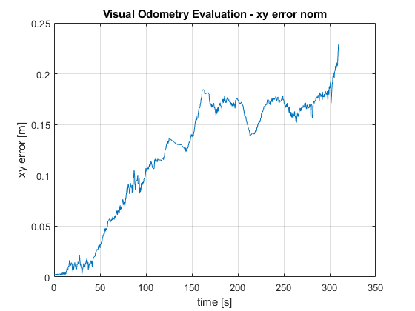

BIBLIOGRAPHY

[1]<http://wkriris.estec.esa.nl/Horde/wicked/display.php?page=ARL%2FExoTeR&referrer=Automation%20and%20Planetary%20Robotics%20lab>

[2] <https://github.com/esa-prl/bundles-exoter/blob/master/scripts/control.rb>

[3] <https://github.com/esa-prl/bundles-exoter/blob/master/scripts/visodom.rb>

[4] <https://github.com/MatteoDeBenedetti/Visual-Odometry-ESA/tree/master/VO_logs_visualization>